port



v1.0

06-September-2022

USER MANUAL

AWS CFT TEMPLATE 3NIC-2VM-HA-GLM-PUBVIP_BACKAUTO

# PATENT PROTECTION

A10 Networks, Inc. products are protected by patents in the U.S. and elsewhere. The following website is provided to satisfy the virtual patent marking provisions of various jurisdictions including the virtual patent marking provisions of the America Invents Act. A10 Networks, Inc. products, including all Thunder Series products, are protected by one or more of U.S. patents and patents pending listed at: a10-virtual-patent-marking.

# TRADEMARKS

A10 Networks, Inc. trademarks are listed at: a10-trademarks.

# CONFIDENTIALITY

This document contains confidential materials proprietary to A10 Networks, Inc. This document and information and ideas herein may not be disclosed, copied, reproduced, or distributed to anyone outside A10 Networks, Inc. without prior written consent of A10 Networks, Inc.

# DISCLAIMER

This document does not create any express or implied warranty about A10 Networks, Inc. or about its products or services, including but not limited to fitness for a particular use and non-infringement. A10 Networks, Inc. has made reasonable efforts to verify that the information contained herein is accurate, but A10 Networks, Inc. assumes no responsibility for its use. All information is provided "as-is." The product specifications and features described in this publication are based on the latest information available; however, specifications are subject to change without notice, and certain features may not be available upon initial product release. Contact A10 Networks, Inc. for current information regarding its products or services. A10 Networks, Inc. products and services are subject to A10 Networks, Inc. standard terms and conditions.

# ENVIRONMENTAL CONSIDERATIONS

Some electronic components may possibly contain dangerous substances. For information on specific component types, please contact the manufacturer of that component. Always consult local authorities for regulations regarding proper disposal of electronic components in your area.

# FURTHER INFORMATION

For additional information about A10 products, terms and conditions of delivery, and pricing, contact your nearest A10 Networks, Inc. location, which can be found by visiting [www.a10networks.com](http://www.a10networks.com/).

Contents

PATENT PROTECTION 1

TRADEMARKS 1

CONFIDENTIALITY 1

DISCLAIMER 1

ENVIRONMENTAL CONSIDERATIONS 1

FURTHER INFORMATION 2

Introduction to Installing vThunder on AWS 5

Overview of AWS 5

Aws Terminology 6

CloudFormation Template – 3NIC _2VM _HA_GLM_PubVIP_BackAuto vThunder 7

Overview 7

Prerequisites 7

AWS Account & Subscription. 7

AWS Account and Environment Setup to Run CFT Template [One Time Step] 7

Steps to create a SSH key [Optional] 9

System Requirements 10

Stack 10

Chapter 1-S3 Bucket Setup 14

Install 14

Verify 14

Chapter 2 – Install vADC 15

Install 15

Chapter 3- AutoScaling Group 20

Chapter 4– Configure vThunder 23

configure 23

Chapter -5 vThunder HA and GLM Setup 31

HA Configuration 31

GLM Configuration 32

Install 34

Chapter 6- Install Client/Server VM 36

Install 36

Chapter 7 - Let us Verify. 37

Slb verification 37

SSL verification 38

HA verification 38

GLM verification 42

# Introduction to Installing vThunder on AWS

vThunder for Amazon Web Services is a fully operational, software-only version of the ACOS Series Server Load Balancer (SLB), or Application Delivery Controller (ADC) device. It is configurable by ACOS CLI, GUI, AXAPI, and Harmony Controller. For more information see Virtual Instances in Harmony Controller.

vThunder is a virtual appliance, yet it retains most of the functionality available on the hardware based ACOS appliances. Managing vThunder is the same as managing hardware based ACOS device, and vThunder has the same CLI configurations and GUI presentation.

The networking configuration for vThunder is also like hardware based ACOS devices.

A10 Networks brings Out-Of-Box template to deploy vThunder along with multiple features and functionality with pre-defined format into amazon cloud.

Please refer below section for more details.

* Three Network Card Interface (3NIC).
* TLS/SSL Certification (SSL).
* Server Load Balancer (SLB).
* Global License Manager Integration (GLM).

# Overview of AWS

Amazon Web Services offers a broad set of global cloud-based products including compute, storage, databases, analytics, networking, mobile, developer tools, management tools, IoT, security, and enterprise applications: on-demand, available in seconds, with pay-as-you-go pricing. From data warehousing to deployment tools, directories to content delivery, over 200 AWS services are available. New services can be provisioned quickly, without the upfront fixed expense.

AWS uses the following tools to create and manage resources:

**AWS Portal** - A web console to create and monitor AWS resources. For more information: <https://aws.amazon.com/console/>

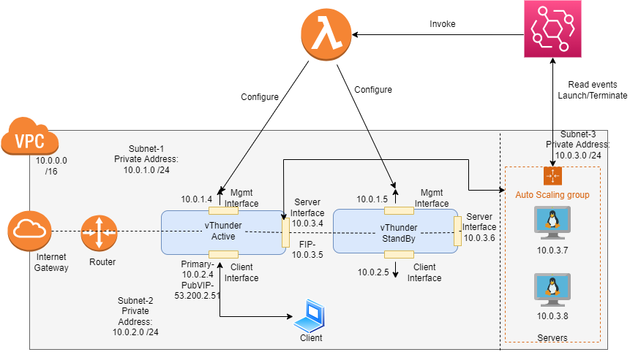

# Aws Terminology

**CloudWatch:** Service that allows you to monitor various elements of your AWS account. For more information: <https://docs.aws.amazon.com/cloudwatch/index.html>

**Elastic Compute Cloud (EC2):** A virtual computer, very similar to a desktop/laptop computer. For more information: <https://docs.aws.amazon.com/AWSEC2/latest/UserGuide/concepts.html>

**Lambda:** Serverless computing that will replace EC2 instances, for the most part. For more information: <https://docs.aws.amazon.com/lambda/latest/dg/welcome.html>

**Security group (SG):** Firewall/security layer on the server/instance level. For more information <https://docs.aws.amazon.com/AWSEC2/latest/UserGuide/ec2-security-groups.html>

**Subnet:** A subsection of a network and generally includes all the computers in a specific location. For more information: <https://docs.aws.amazon.com/AWSCloudFormation/latest/UserGuide/aws-resource-ec2-subnet.html>

**Virtual Private Cloud (VPC):** A private subsection of AWS you control and in which you can place AWS resources. For more information: <https://docs.aws.amazon.com/vpc/latest/userguide/what-is-amazon-vpc.html>

# 

# CloudFormation Template – 3NIC _2VM _HA_GLM_PubVIP_BackAuto vThunder

## Overview

CloudFormation template to create 3NIC 2 vThunder instances and autoscaling group on AWS portal.

## Prerequisites

### AWS Account & Subscription.

Generate access_key_id and secret_access_key if you don’t have it. For more details visit:

<https://docs.aws.amazon.com/powershell/latest/userguide/pstools-appendix-sign-up.html>

### AWS Account and Environment Setup to Run CFT Template [One Time Step]

1. Download and install python setup using following link:

<https://www.python.org/ftp/python/3.8.5/python-3.8.5-amd64.exe>

1. To verify that Python is available on our local machine, we need to open the command line (in Windows search, type cmd and press Enter to open Command Prompt or right-click on the Start button and select Windows Command Prompt), type python, and press Enter.
2. If Python is properly installed, we will see a notification like the one below:

*Python 3.8.x (tags/v3.10.2:a58ebcc, Jan 17 2022, 14:12:15) [MSC v.1929 64 bit (AMD64)] on win32 Type "help," "copyright," "credits," or "license" for more information.*

1. To check if PIP is already installed on Windows, we should open the command line again, type pip, and press Enter.
2. If PIP is installed, we will receive a long notification explaining the program usage, all the available commands and options. Otherwise, if PIP is not installed, the output will be:

*'pip' is not recognized as an internal or external command, operable program or batch file.*

1. To install pip on window visit:

[https://pip.pypa.io/en/stable/installation](https://pip.pypa.io/en/stable/installation/)

1. Install all dependencies go to current working directory and use following command:

pip install -r requirements.txt

1. Locate and open /credentials in current working directory.
2. Change the access key as well as secret access key as per your aws account.

*Copy credentials file to C:\Users\<USERNAME>\.aws*

1. Locate and open /config in current working directory.
2. Change aws region details.

1. Copy AWS config file on your local system, located at:

*C:\Users\<USERNAME>\.aws*

**For linux, macOS, Unix**:

1. Locate and open /credentials.
2. Change the access key as well as secret access key as per your aws account.

*Copy credentials file to ~/.aws*

1. Locate and open /config
2. Change aws region details.

1. Copy AWS config file on your local system, located at:

*~/.aws*

For more information: https://docs.aws.amazon.com/sdk-for-java/v1/developer-guide/setup-credentials.html

## Steps to create a SSH key [Optional]

Note: You can use existing key pair if you have key pair already created.

1. Go to the EC2 dashboard and click on key pairs.

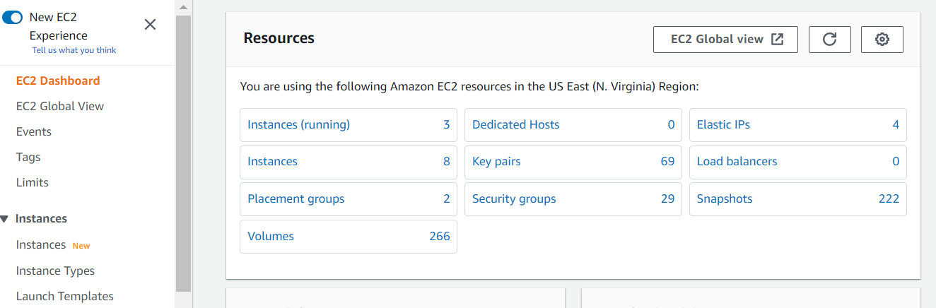

1. Now click on create key pair at the top right.



1. Now name the key and select the key pair type as RSA and key file format as .pem.

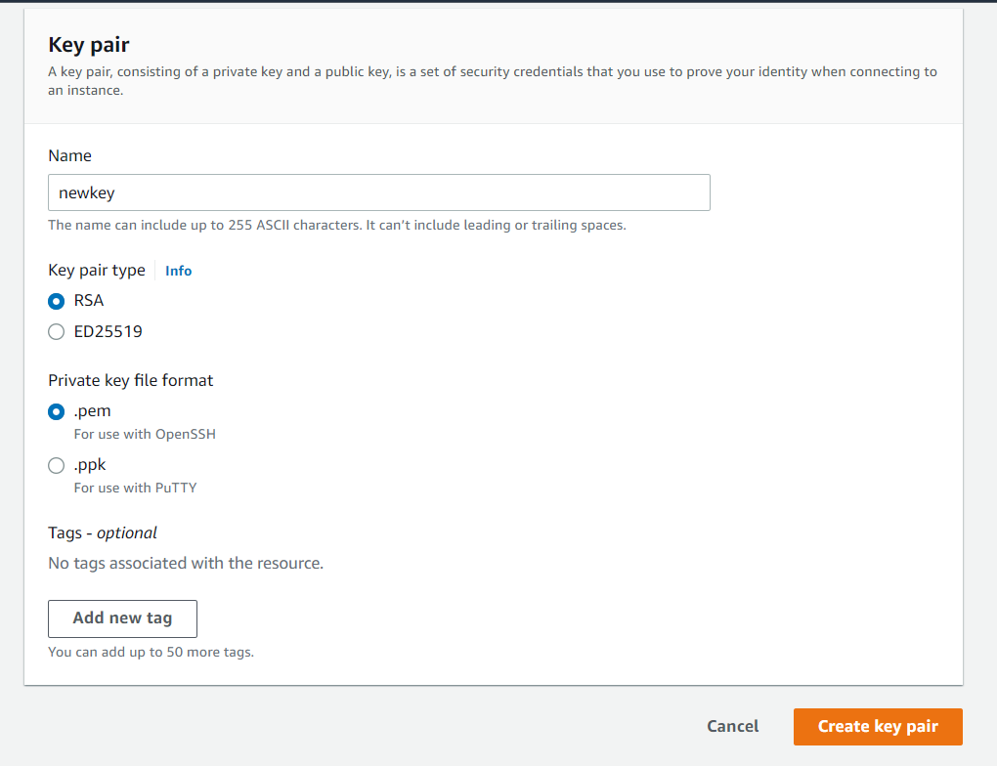

## System Requirements

Below all AWS cloud resources will be created.

All templates come with default value it can be change while execution.

Stack

A new stack is created with the specified name and location.

**Interfaces**

For both vThunder 1 management and 2 data interfaces will be created.

Default names:

|  |
| --- |
| *<vth>-inst1-mgmt-nic1* |
| *<vth>-inst1-data-nic2* |
| *<vth>-inst1-data-nic3* |
| *<vth>-inst2-mgmt-nic1* |
| *<vth>-inst2-data-nic2* |
| *<vth>-inst2-data-nic3* |

**Subnets**

Total 3 subnets will be created.

Default names:

*<vth>-vpc-mgmt-sub1*

*<vth>-vpc-data-sub1*

*<vth>-vpc-data-sub2*

**Virtual Private Network**

A virtual Private network will be created. Address prefix is 10.0.0.0/16.

Default name*: <vth>-vpc*

**Elastic Public Ip**

Elastic Public Ip will be created and attached to management and client interface of active vThunder and to only management interface standby vThunder instance.

Default name:

*<vth>-inst1-mgmt-nic1-ip*

*<vth>-inst1-data-nic1-ip*

*<vth>-inst2-mgmt-nic1-ip*

**Security Group**

Two Security Group will be created. One will be attached to management interface and one for data interfaces

Default name:

*<vth>-sg-mgmt*

*<vth>-sg-data*

Path: *Stacks>> {stack-name}->> Resources>> vThunderSecurityGroup*

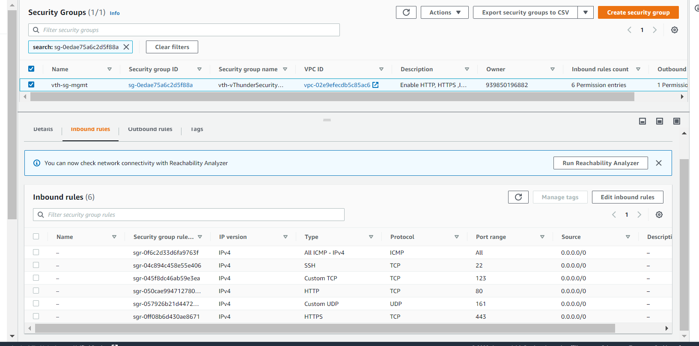

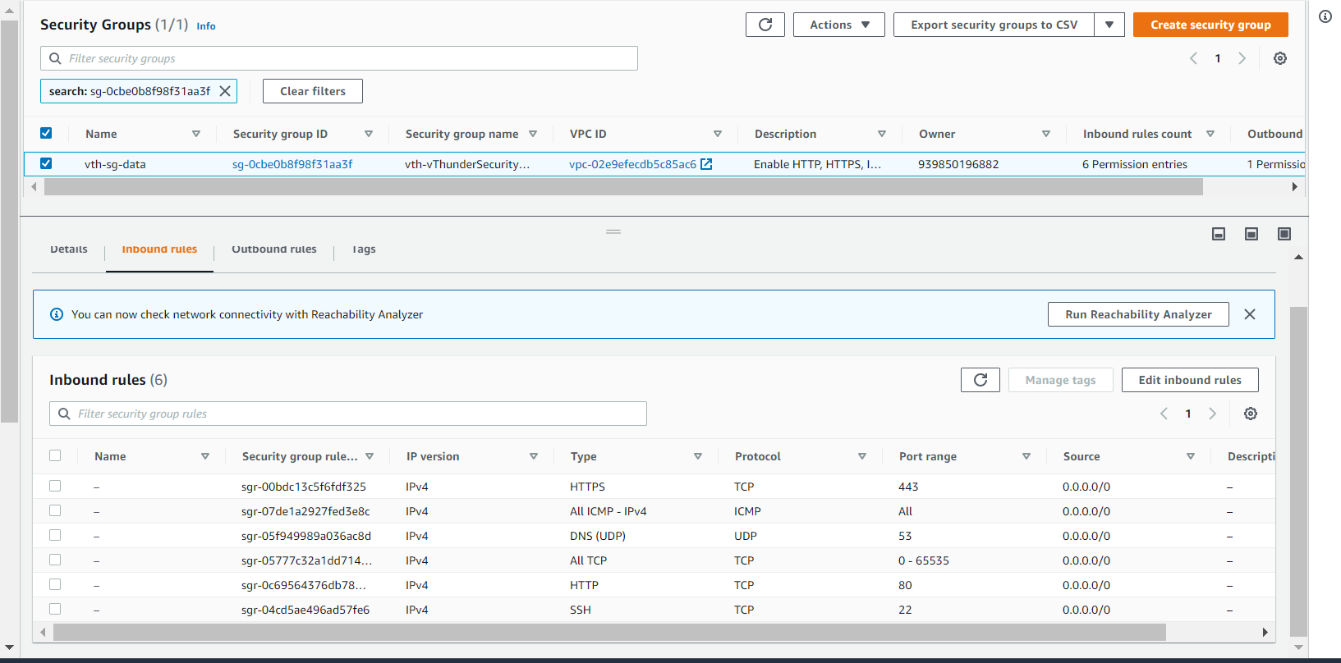

***Note****: If you want to add new rule to security group then select security group and then edit inbound rule and add rule and save.*

**vThunder Instance**

1 vThunder ec2 instance will be created.

Default Size: m4.xlarge (40 Gb memory)

Default name: *<vth>-inst1, <vth>-inst2*

**Lambda Function**

Lambda function is created, and the code is uploaded from S3 bucket.

Default name: *<vth>-lambda-function*

**EventBus**

EventBus is created and event rules are added.

Default name: *<vth>-eventbus*

**AutoScaling Group**

AutoScaling group is created to add or delete instances as needed.

Default name*: <vth>-auto-scale-group*

# Chapter 1-S3 Bucket Setup

## Install

1. Run the python file CFT_TMPL_3NIC_2VM_HA_GLM_PUBVIP_BACKAUTO_SERVER_PACKAGE_S3_1.py to create a S3 bucket and store lambda function python script.

$Python ./CFT_TMPL_3NIC_2VM_HA_GLM_PUBVIP_BACKAUTO_SERVER_PACKAGE_S3_1.py

## Verify

1. To verify the S3 bucket follow the path given:

Path: S3 Bucket>>vth-3nic-2vm-ha-glm-pubvip-backauto-bucket

# 

# Chapter 2 – Install vADC

All resources will get created in AWS.

## Install

1. Navigate to AWS Console -> CloudFormation -> Stacks -> Create Stack
2. Select prepare template.
3. Select “Upload a template file”.
4. Choose file CFT_TMPL_3NIC_2VM_HA_GLM_PUBVIP_BACKAUTO_2.json
5. Go to next.
6. Provide stack name. For example: <vth>
7. Provide availability zone. For example: us-east-1a
8. Provide tagValue. For example: <a10-vthunder-adc>
9. Confirm default values.

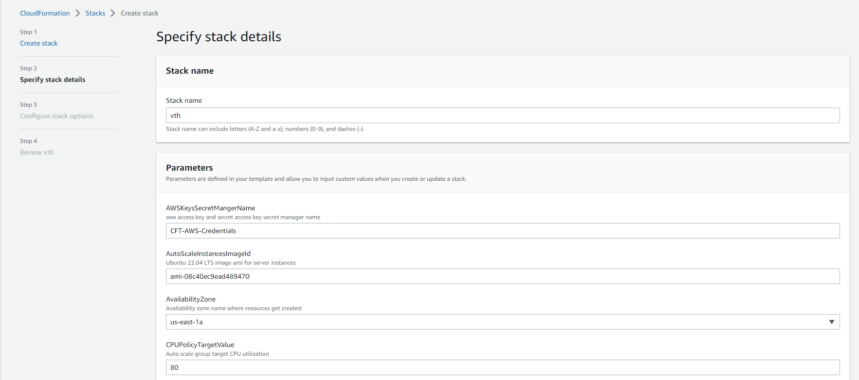

***Note:*** *User can add new values of below parameters or can use provided default values.*

1. Below listed sizes are verified for vThunder.

|  |  |  |  |
| --- | --- | --- | --- |
| **Instance** | **vCPU** | **Memory** | **Number of Network Interfaces** |
| c4.xlarge | 4 | 7680 | 4 |
| c4.4xlarge | 16 | 30720 | 8 |
| c4.8xlarge | 36 | 61440 | 8 |
| d2.xlarge | 4 | 31232 | 4 |
| d2.2xlarge | 8 | 62464 | 4 |
| d2.4xlarge | 16 | 124928 | 8 |
| d2.8xlarge | 36 | 249856 | 8 |
| m4.xlarge | 4 | 16384 | 4 |
| m4.2xlarge | 8 | 32768 | 4 |
| m4.4xlarge | 16 | 65536 | 8 |
| m4.10xlarge | 40 | 163840 | 8 |
| i2.xlarge | 4 | 31232 | 4 |
| i2.2xlarge | 8 | 62464 | 4 |
| i2.4xlarge | 16 | 124928 | 8 |
| i2.8xlarge | 32 | 249856 | 8 |
| c5d.large | 2 | 4096 | 3 |
| c5d.9xlarge | 36 | 73728 | 8 |
| c5d.2xlarge | 8 | 32768 | 4 |
| c5d.4xlarge | 16 | 73728 | 8 |
| c5.xlarge | 4 | 8192 | 4 |
| c5.2xlarge | 8 | 16384 | 4 |
| c5.4xlarge | 16 | 32768 | 8 |
| c5.9xlarge | 36 | 73728 | 8 |
| g3.4xlarge | 16 | 124928 | 8 |
| g3.8xlarge | 32 | 249856 | 8 |
| i3.large | 2 | 15616 | 3 |
| i3.xlarge | 4 | 31232 | 4 |
| i3.2xlarge | 8 | 62464 | 4 |
| i3.4xlarge | 16 | 124928 | 8 |
| i3.8xlarge | 32 | 249856 | 8 |
| m5d.large | 2 | 8192 | 3 |
| m5d.xlarge | 4 | 16384 | 4 |
| m5d.2xlarge | 8 | 32768 | 4 |
| m5d.4xlarge | 16 | 65536 | 8 |
| m5.large | 2 | 8192 | 3 |
| m5.xlarge | 4 | 16384 | 4 |
| m5.2xlarge | 8 | 32768 | 4 |
| m5.4xlarge | 16 | 65536 | 8 |
| r5d.large | 2 | 16384 | 3 |
| r5d.xlarge | 4 | 32768 | 4 |
| r5d.2xlarge | 8 | 65536 | 4 |
| r5d.4xlarge | 16 | 131072 | 8 |
| r5.large | 2 | 16384 | 3 |
| r5.xlarge | 4 | 32768 | 4 |
| r5.2xlarge | 8 | 65536 | 4 |
| r5.4xlarge | 16 | 131072 | 8 |
| r4.large | 2 | 15616 | 3 |
| r4.xlarge | 4 | 31232 | 4 |
| r4.2xlarge | 8 | 62464 | 4 |
| r4.4xlarge | 16 | 124928 | 8 |
| r4.8xlarge | 32 | 249856 | 8 |
| t3.medium | 2 | 4096 | 3 |
| t3.large | 2 | 8192 | 3 |
| t3.xlarge | 4 | 16384 | 4 |
| t3.2xlarge | 8 | 32768 | 4 |
| z1d.large | 2 | 16384 | 3 |
| z1d.xlarge | 4 | 32768 | 4 |
| z1d.2xlarge | 8 | 65536 | 4 |
| z1d.3xlarge | 12 | 98304 | 8 |
| z1d.6xlarge | 24 | 196608 | 8 |

11) Remain others as default.

12) Go to next.

13) Review

14) Submit

***Set Back and Relax, it will take maximum 10 mins. 😊***

1. Go to AWS Console -> *CloudFormation-> Stacks-> {stack name}*

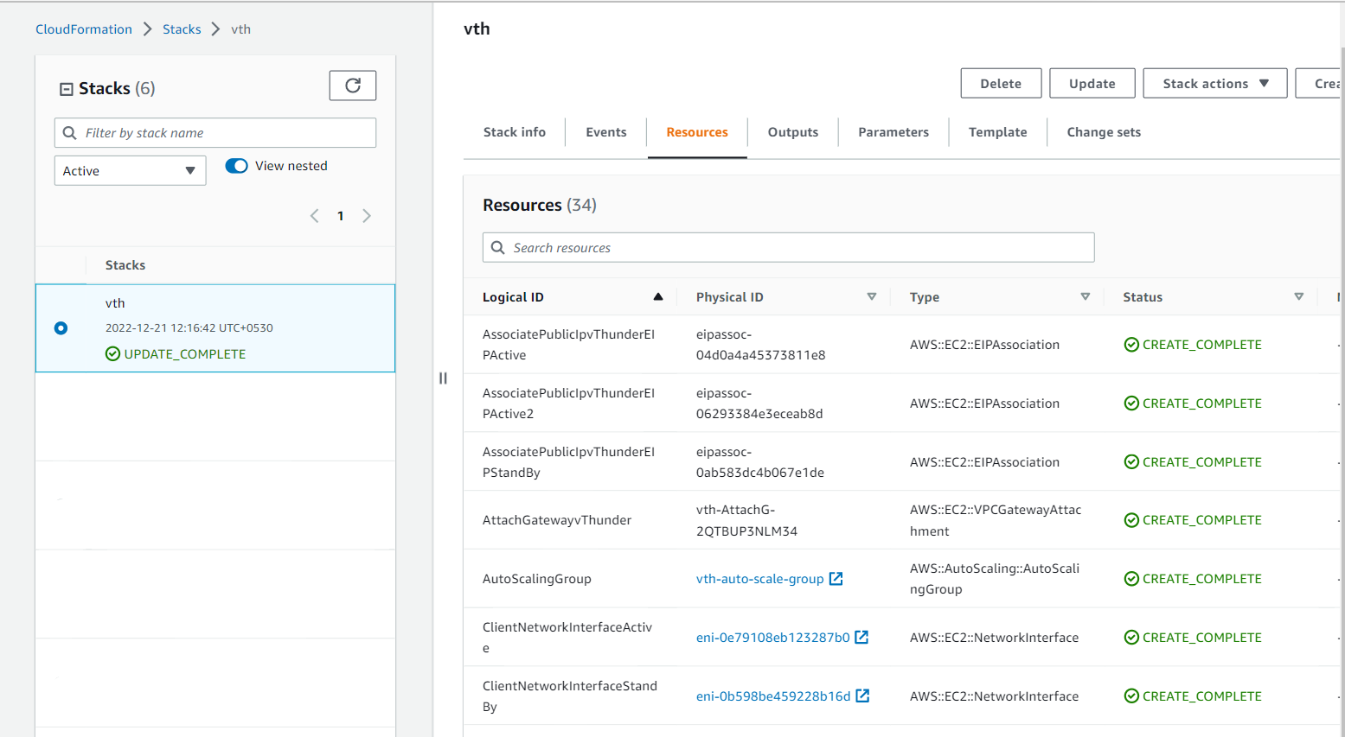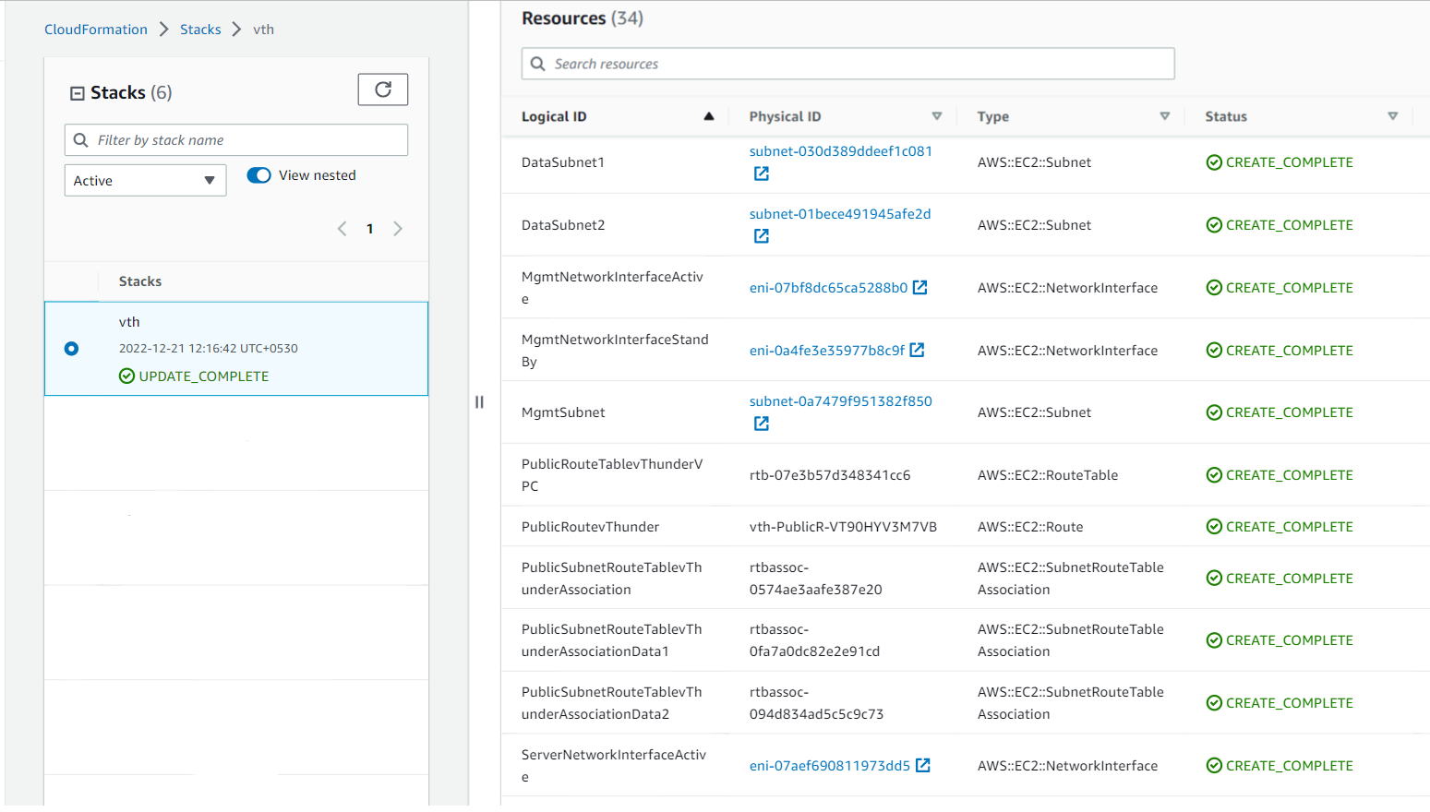

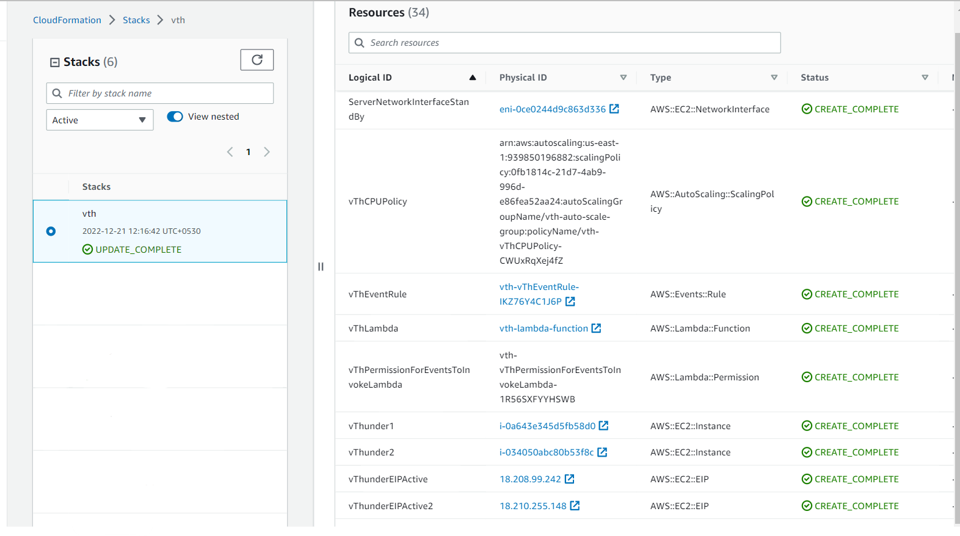

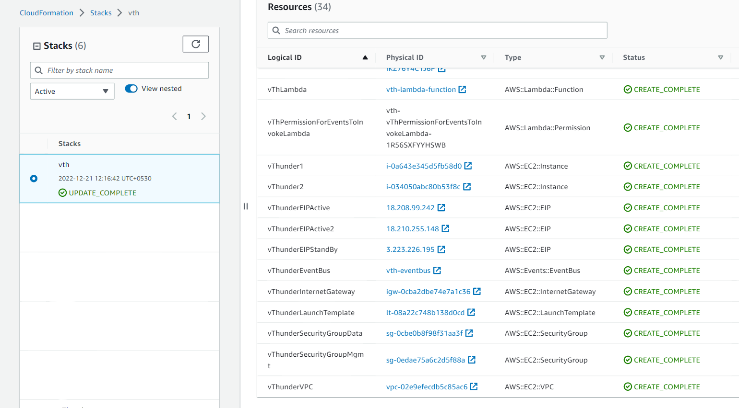

15) Verify all above resources created.

***Verify status check of vThunder instance we created.***

EC2-> Instances*-> <vth>-inst1*

Open any browser and type http://<vthunder_public_IP>

Enter username – admin

Enter Password – {ec2 instance id}

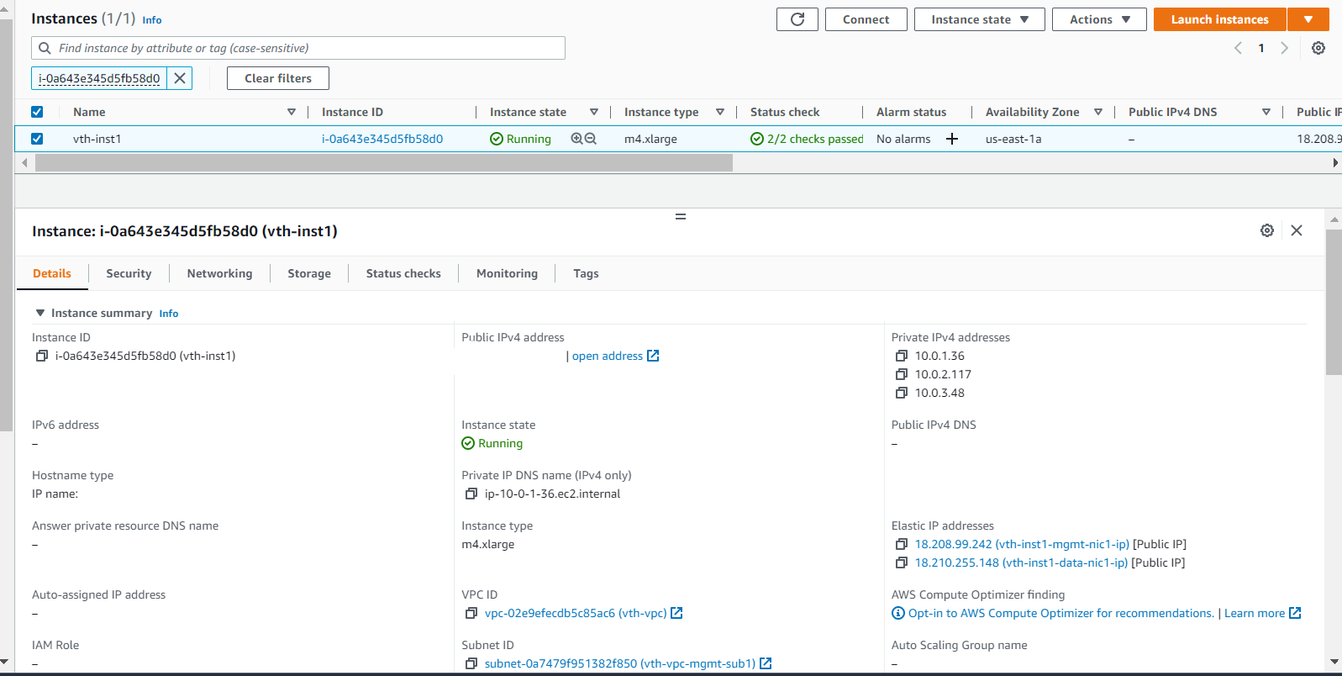

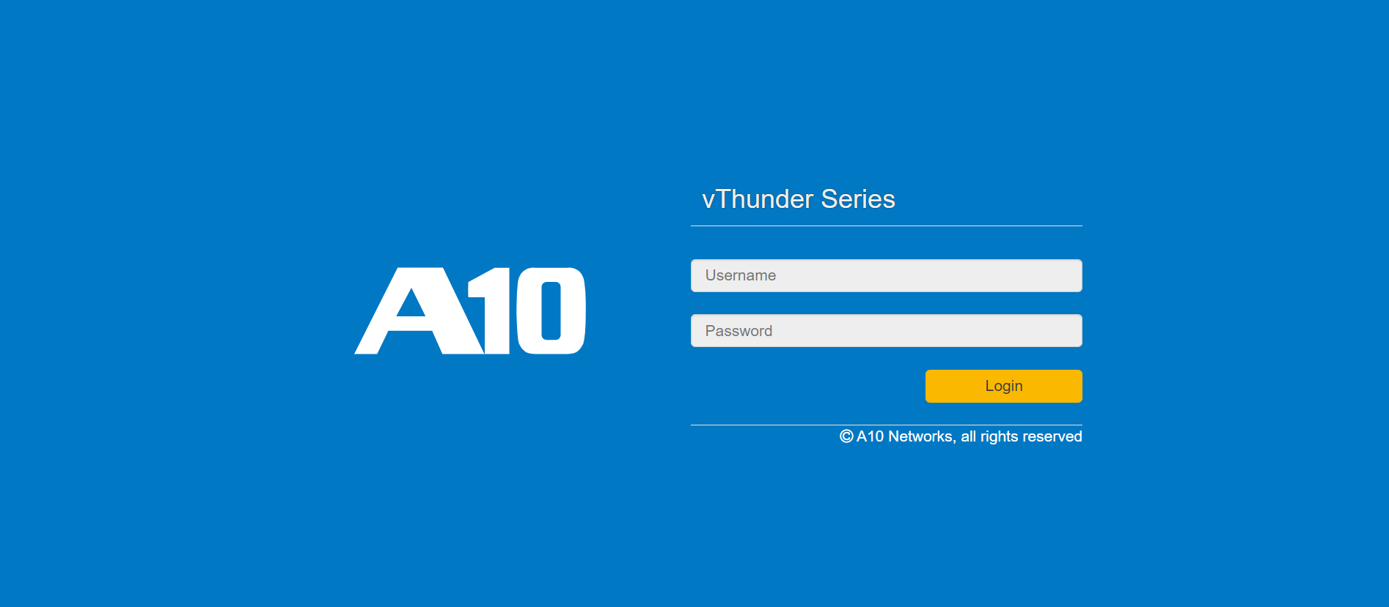

# Chapter 3- AutoScaling Group

1. To add or delete the server follow the path given [Verify Only]:

Note: For autoscaling group servers we are using CPU utilization policy, but for testing purpose we can manually update Desired capacity.

Path: *CloudFormation>> Stacks>>{stack-name}>> AutoScalingGroup>>* [*{stack-name}-auto-scale-group*](https://us-east-1.console.aws.amazon.com/ec2/home?redirectFrom=asg&region=us-east-1#AutoScalingGroupDetails:id=vth-stack1-auto-scale-group;view=details)

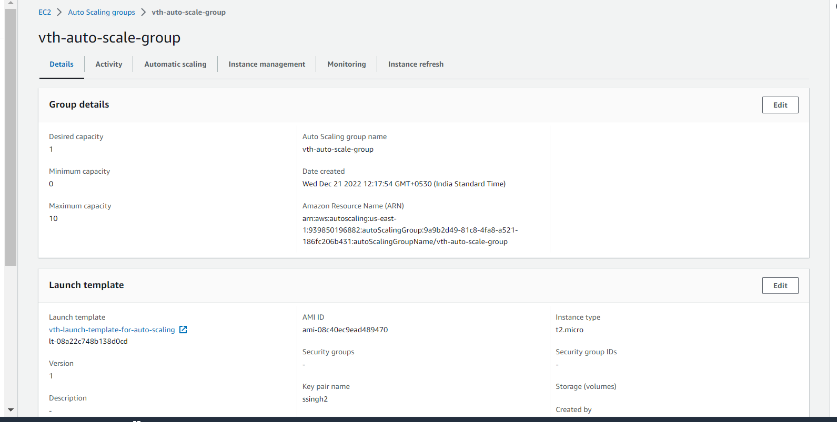

1. Here click on edit to add or delete servers.

Note: before adding or deleting, ssh vthunder1 to check if its reachable.

1. Copy the public Ip to new SSH A session window of MobaxTerm and paste it in host.
2. In specify username write admin and in use private key upload your keys.
3. To copy the public ip follow the path:

*EC2>> Instances>> {stack-name}-inst1*



# Chapter 4– Configure vThunder

Here we will run python script and which will configure SLB and SSL to vThunder.

## configure

1. In parameter file CFT_TMPL_3NIC_2VM_HA_GLM_PUBVIP_BACKAUTO_CONFIG_SSL_SLB_HA_GLM_PARAM.json
2. add stack name which got created using CFT template.

Default Name: vth

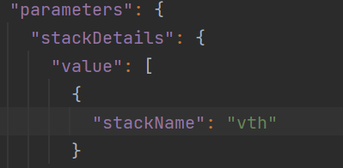

**b) Service Group**

Note: Service group name by default is **“sg+port_number”**, If you want to change service group name then after changing name do respective changes in Virtual servers also.

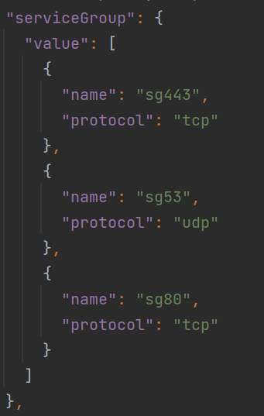

**c) Services Details**

Default values of service group is **“sg+port_number”.** You can modify service details in parameter file.

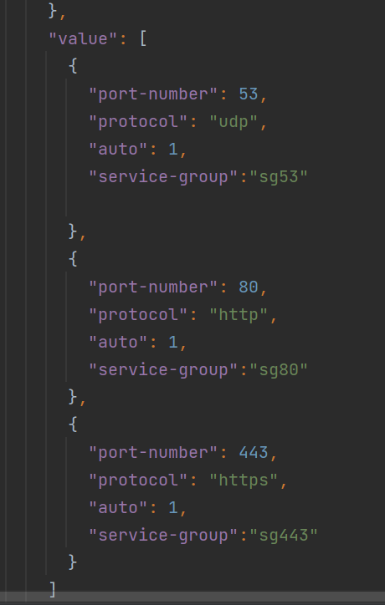

1. **SSL parameters**

Path- Should be the absolute path of the file

File- Name of the file

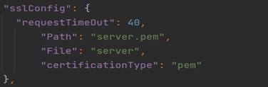

Note: Supported certification type *.pem*.

**Import AWS keys [Using FTP Server]**

Note: Below steps are for transferring AWS keys to vThunder instance. Here we need to create FTP server. You can use existing FTP server if you have [Skip step a].

1. Launch an ubuntu EC2 instance in the same subnet as that of the instance 1.

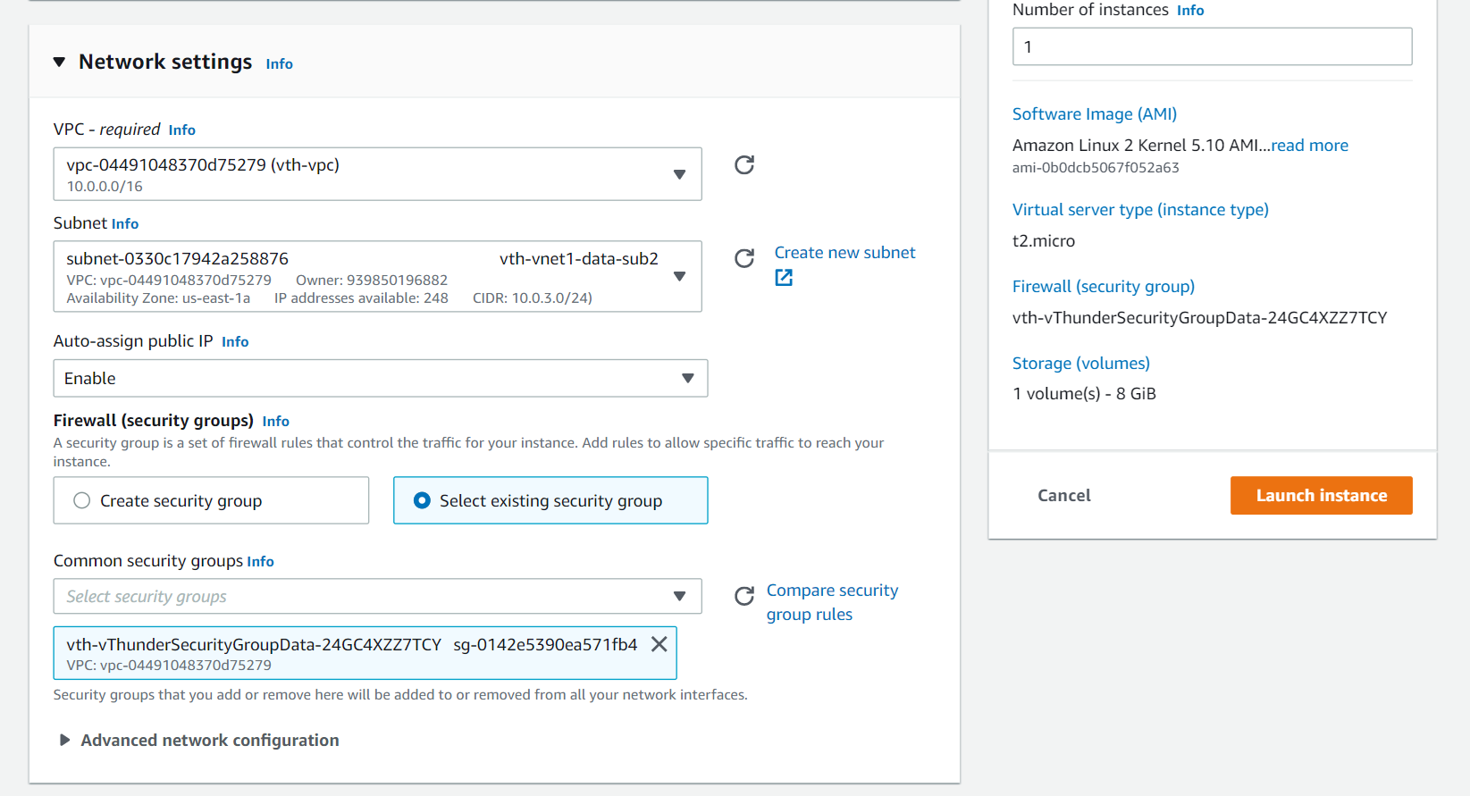

1. Add new rule in security group.

Path: EC2>> Security Groups>> {stack-Name}-sg-data>> Edit inbound rules

***Note****: All TCP rule is only to transfer AWS keys to vthunder instance.*

1. Now copy the public ip of the instance.

1. paste this Ip to new session window of MobaxTerm and paste it in host.

1. Upload the access key in the instance.
2. Create aws_access_key.txt and add aws_access_key_id as well as aws_ secret_access_key.

Example:

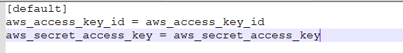

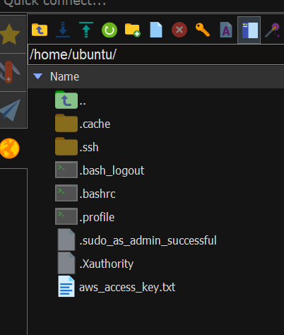

1. Run the command given below to provide the uploaded file permission with read and write permission.

sudo chmod 777 aws_access_key.txt

1. Run the following commands.

sudo apt update

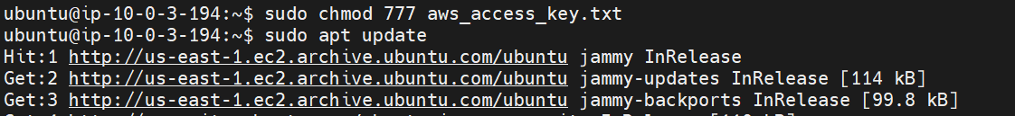

sudo apt upgrade

1. Run the following command to download ftp

sudo apt-get install vsftpd

1. Run the following command to start the ftp.

sudo systemctl start vsftpd

sudo systemctl enable vsftpd



1. Run the following commands to add the new user and set password.

sudo useradd -m vth-user

sudo passwd vth-user

1. Go to the folder where you have uploaded AWS keys.

cd /etc/

1. Now give it write permission

sudo vi vsftpd.conf



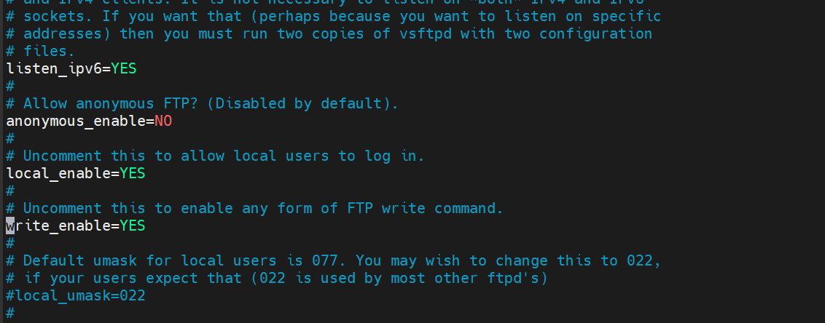

1. Restart the ftp using commands

sudo systemctl restart vsftpd

cd /home/ubuntu

ftp localhost

1. Put the access keys in the instance.

put aws_access_key.txt

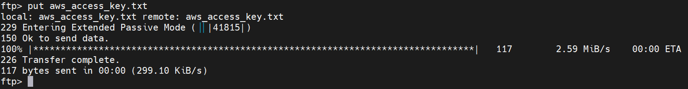

1. Now access the both the vthunder using its public ip and import the access keys using the given command to both.

admin admin

aws-accesskey import use-mgmt-port <ftp://vth-user@publicipof>theinstancewithkeys

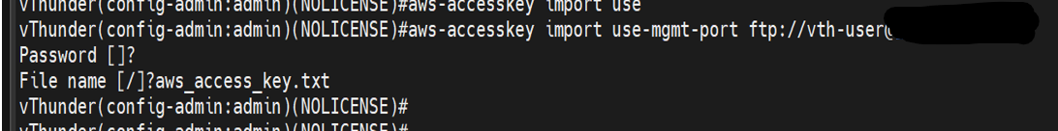

You can check keys with following command.

aws-accesskey show

# Chapter -5 vThunder HA and GLM Setup

## HA Configuration

**DNS**

* 1. Default value is google dns address.

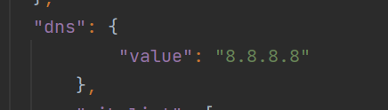

**Network Gateway IP**

1. Default value of network gateway ip address for data subnet is 10.0.2.1.
2. Default value of network gateway ip address for management subnet is 10.0.1.1.

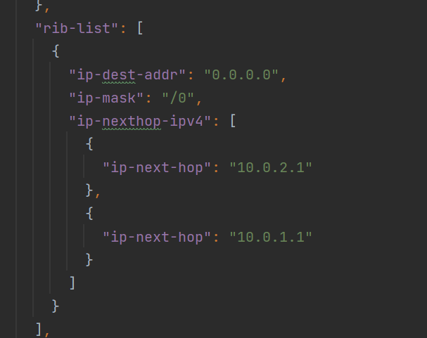

**Vrrp**

1. Default value of set id is 1

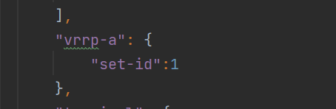

**Terminal Idle Timeout**

1. Default value for idle timeout is 0

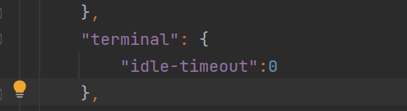

**Vrid**

1. Default value of vrid is 0
2. Default priority for vThunder-1 is 100, and vThunder-2 will have 99 (100-1) priority.

**AWSSecretManagerName**

1. Enter AWS secret manager name in parameter file.

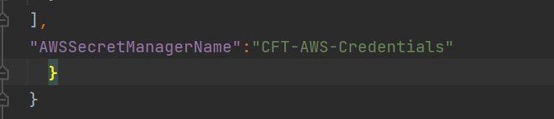

**Server port list**

1. If you want to change server port number you can do it by parameter file.

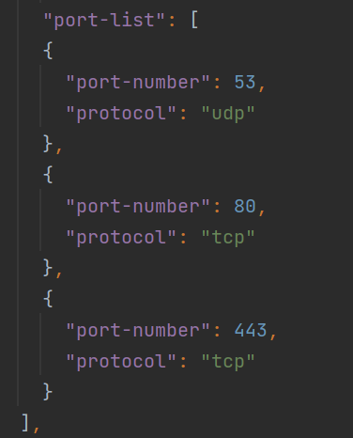

## GLM Configuration

LOGIN

* 1. Go to <https://glm.a10networks.com>
  2. Now enter valid email id.

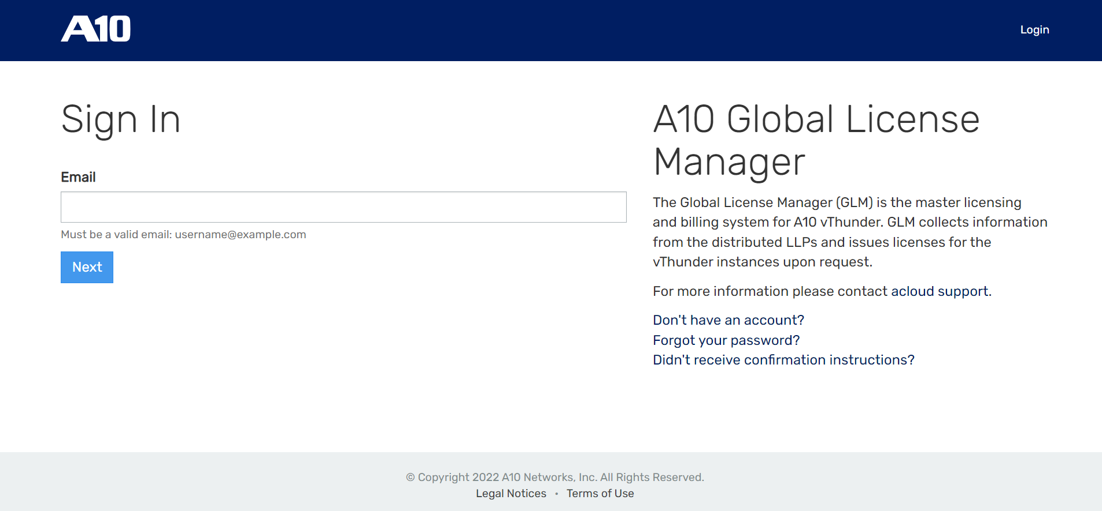

* 1. Enter the password for the entered email-id

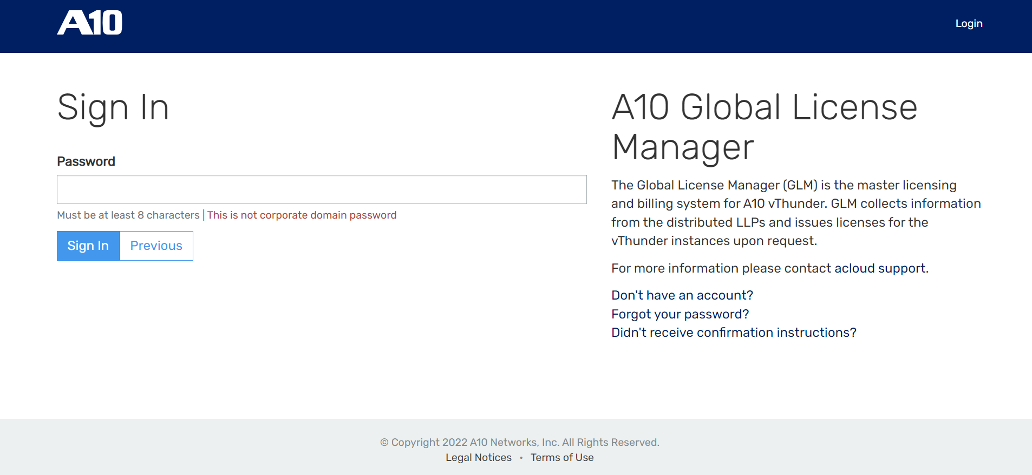

* 1. Add username, password and entitlement token in parameter file.

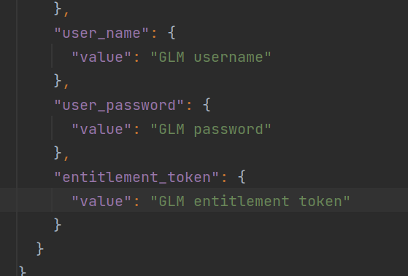

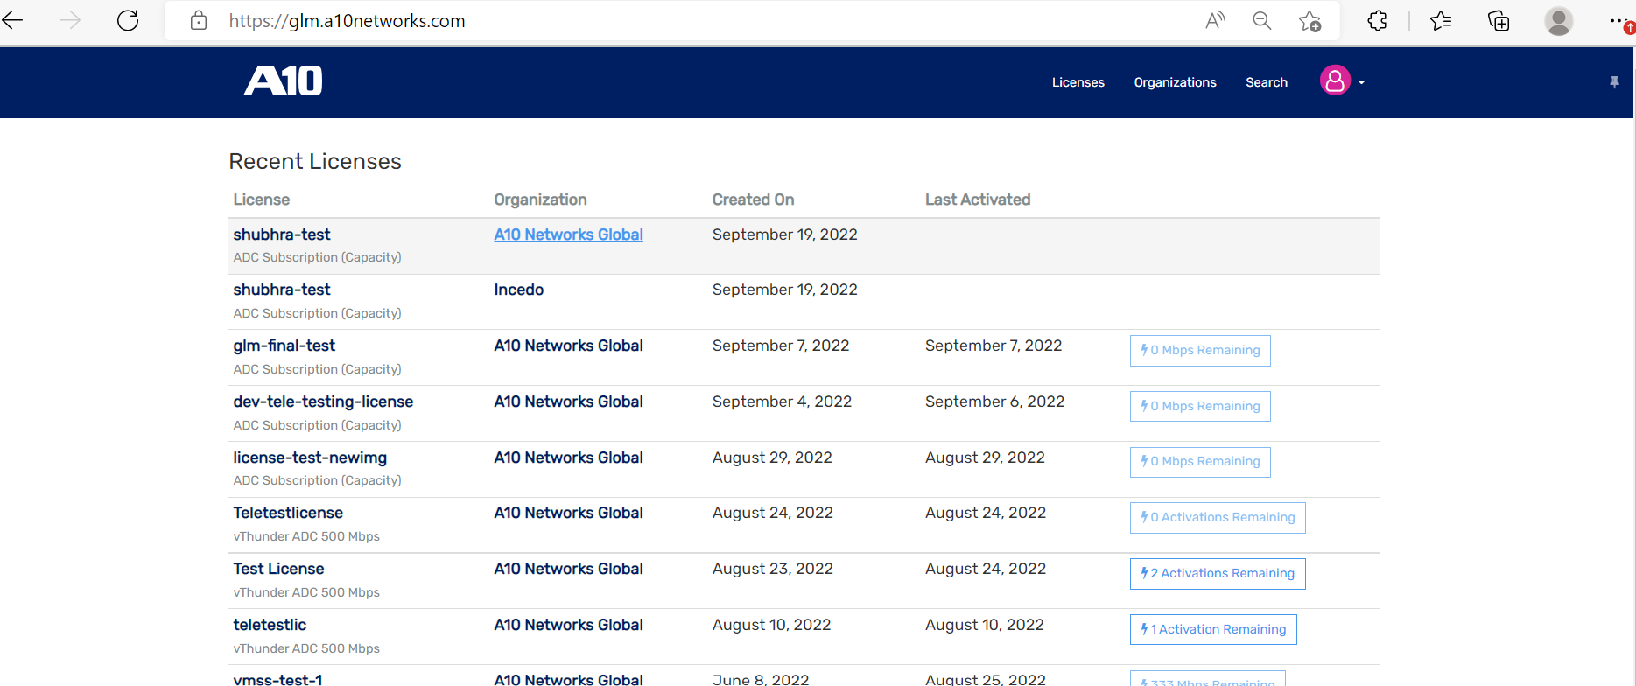

* 1. And then click on any license given and get an entitlement token.

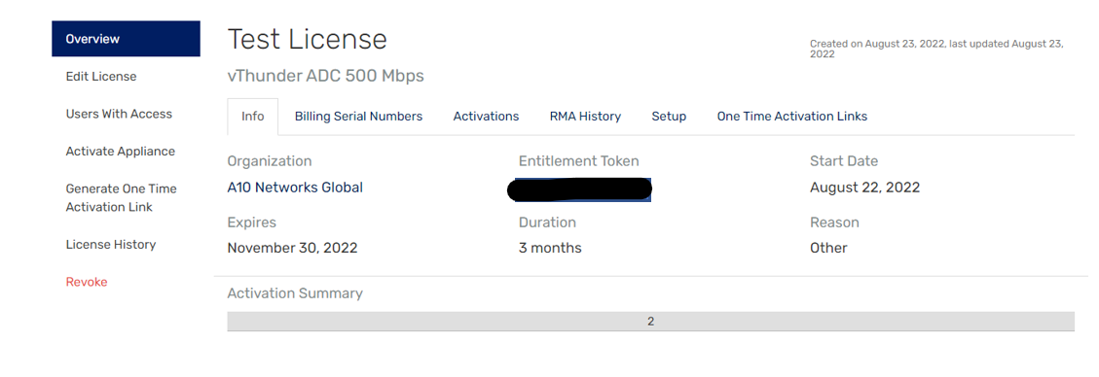

## Install

Open your CMD in current working directory.

Run : Python ./CFT_TMPL_3NIC_2VM_HA_GLM_PUBVIP_BACKAUTO_CONFIG_SSL_SLB_HA_GLM_3.py

Provide below configuration params:

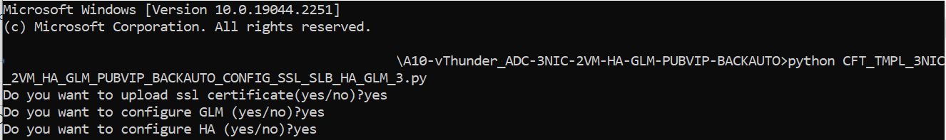

# 

# Chapter 6- Install Client/Server VM

Client VM and Server VM is a temparatory vm which can be deleted later. This will help to test traffic. We can test traffic from client vm to server vm via vThunder.

## Install

Apache Server VM:

Go to AWS Console -> *EC2 -> Instances - > Select <vth>-server -> connect -> EC2 instance connect -> Connect*

Run : sudo apt install apache2

Client VM:

1. Go to AWS Console -> *EC2 -> Instances -> Launch instances*



1. Provide instance name. For example: <vth-client>.
2. Select image as Ubuntu.
3. Select keypair as you created earlier.
4. Edit the network settings. Select VPC <vth-vpc>.
5. Select Data subnet 1. (e.g 10.0.2.0/24)
6. Edit Auto Assign Public IP to enable.
7. Edit Firewall (security groups) and select existing security group <vth-vThunderSecurityGroupData>.
8. Click on launch instance.
9. Wait for 5 min.

# Chapter 7 - Let us Verify.

vThunder can be access by ssh to instance or GUI.

SSH to vThunder Instance:

Open MobaXterm and connect.

IP: Get from AWS Console -> Cloudformation template -> created stack name -> Resources-> vthunder->public ip.

Username [Default]: admin

After login.

Execute Command -> enable

Password -> <just press enter>

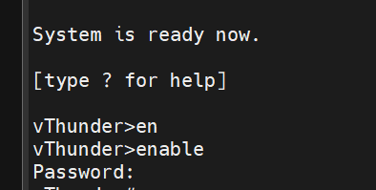

Execute Command -> configure

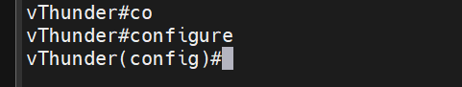

### Slb verification

Execute Command -> *show running-config*

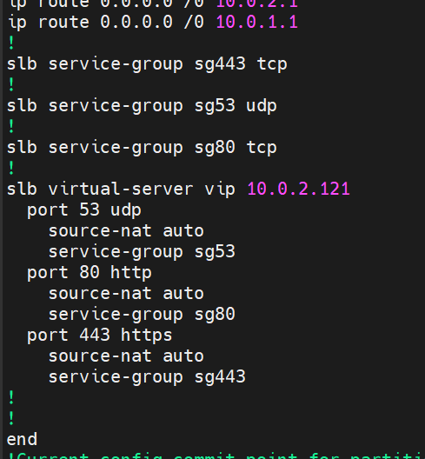

### SSL verification

Execute Command -> *show pki cert*

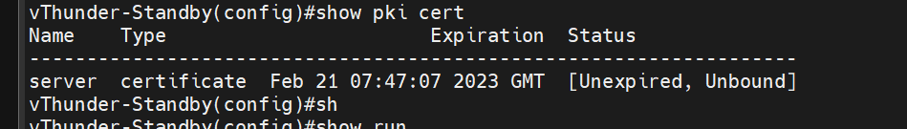

### HA verification

Execute Command -> *show running-config*

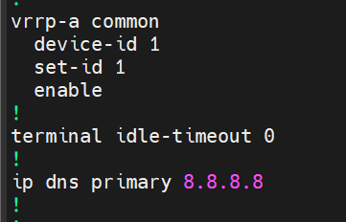

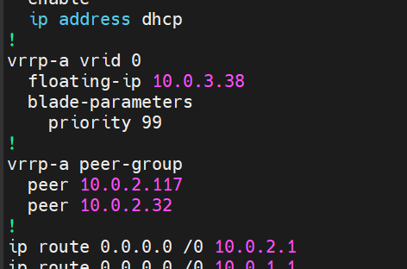

Path: *EC2>> Instances>> {stack-name}-inst1>> Networking*

vth-inst1

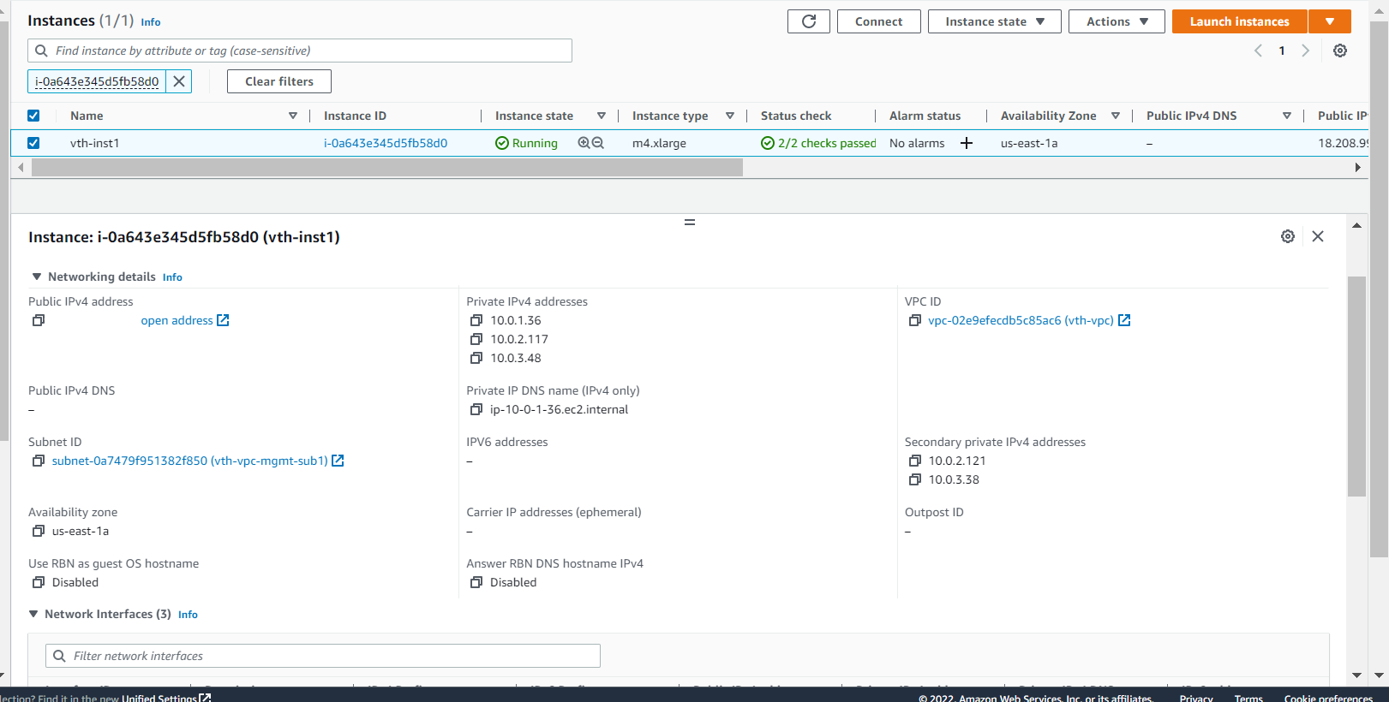

vth-inst2

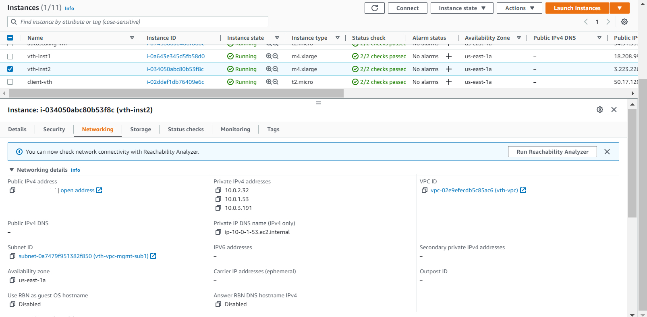

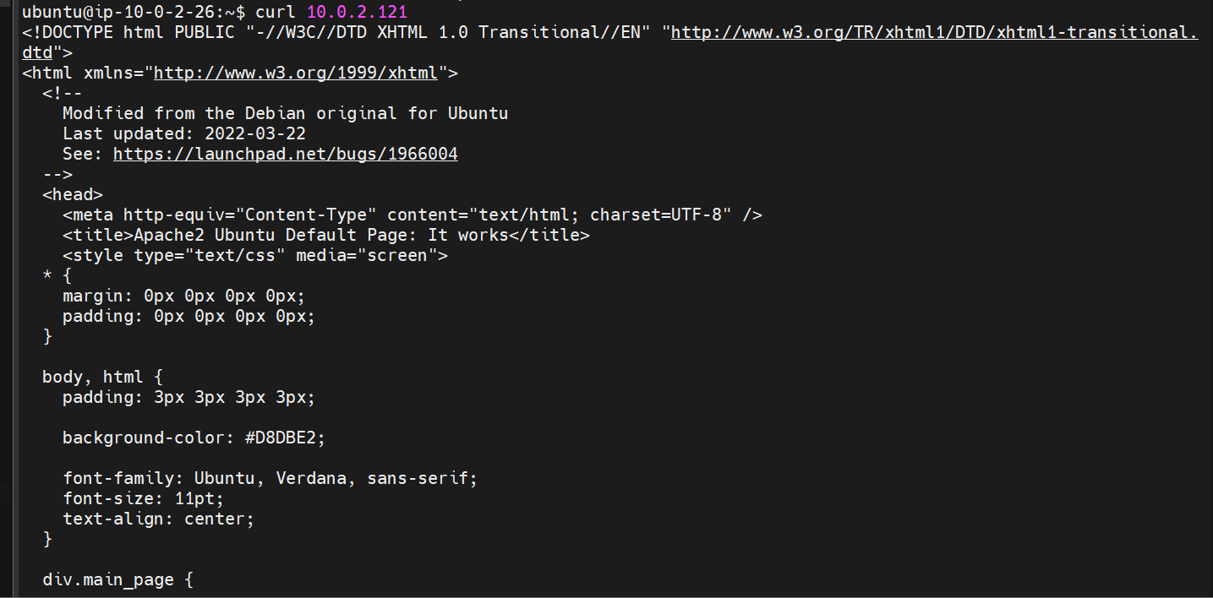

Public IP can be found using below path:

*Instances >> {stack-name}-inst1 >> Networking >> Elastic IP address >> copy ‘Allocated IPv4 address’ of <vth>-inst1-data-nic1-ip*

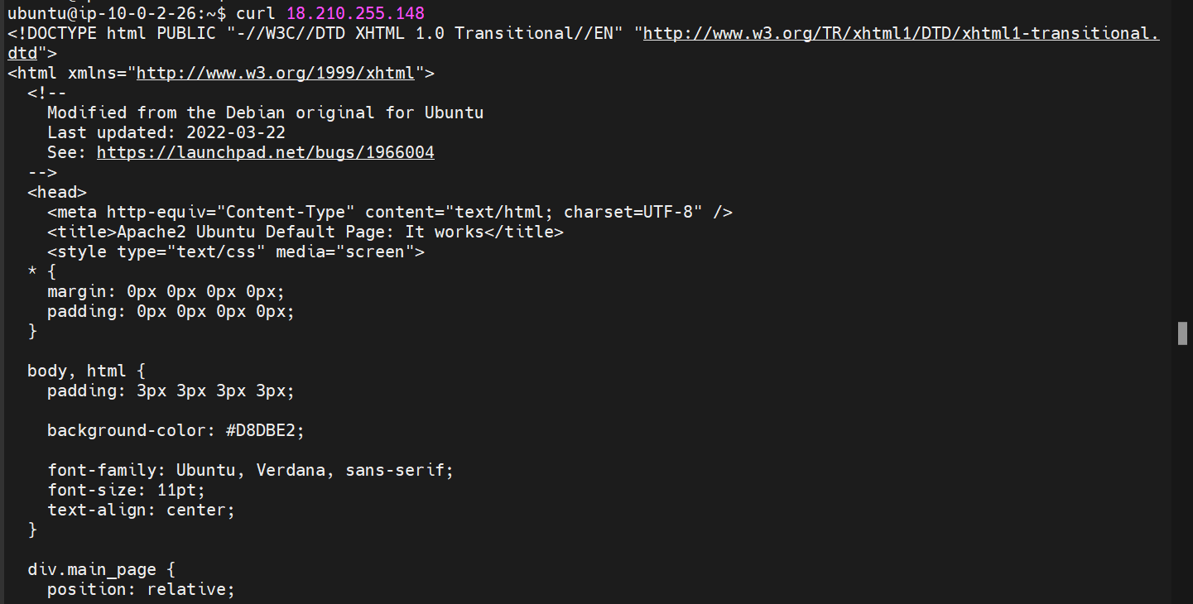

Run the following command to force stop the active vThunder and make standby to active.

*vrrp-a force-self-standby enable*

vth-inst1

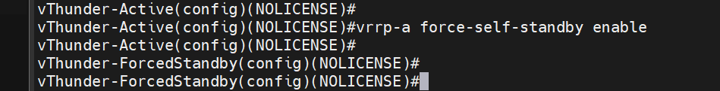

vth-inst2

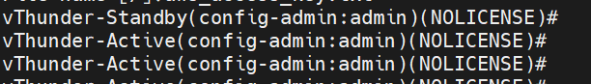

vth-inst1

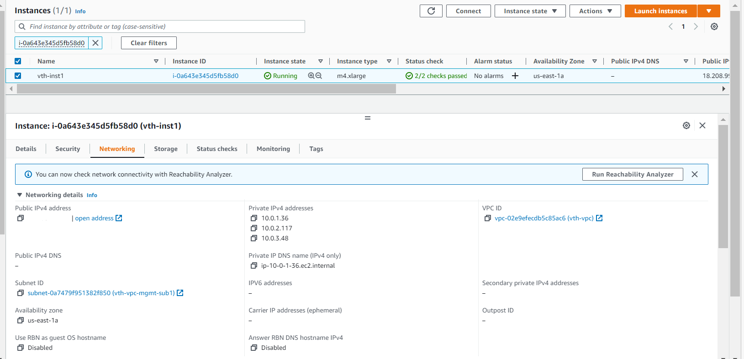

vth-inst2

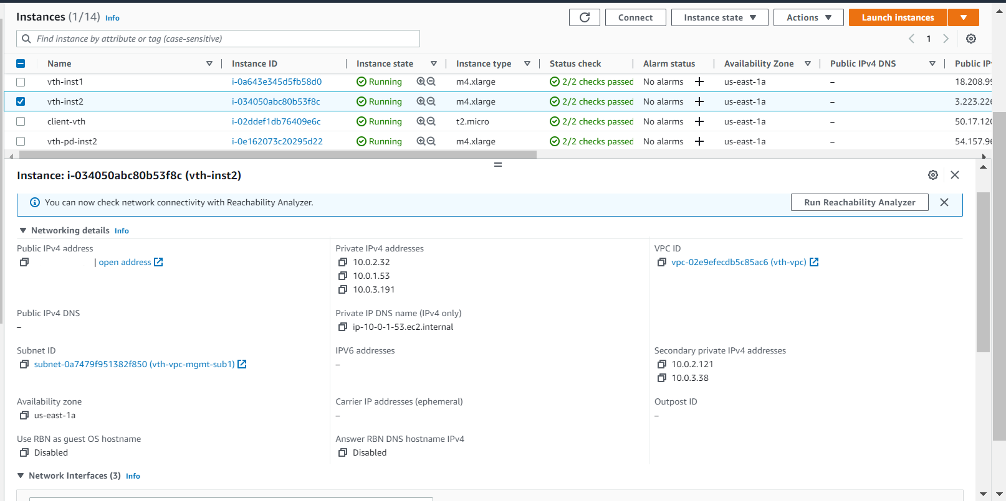

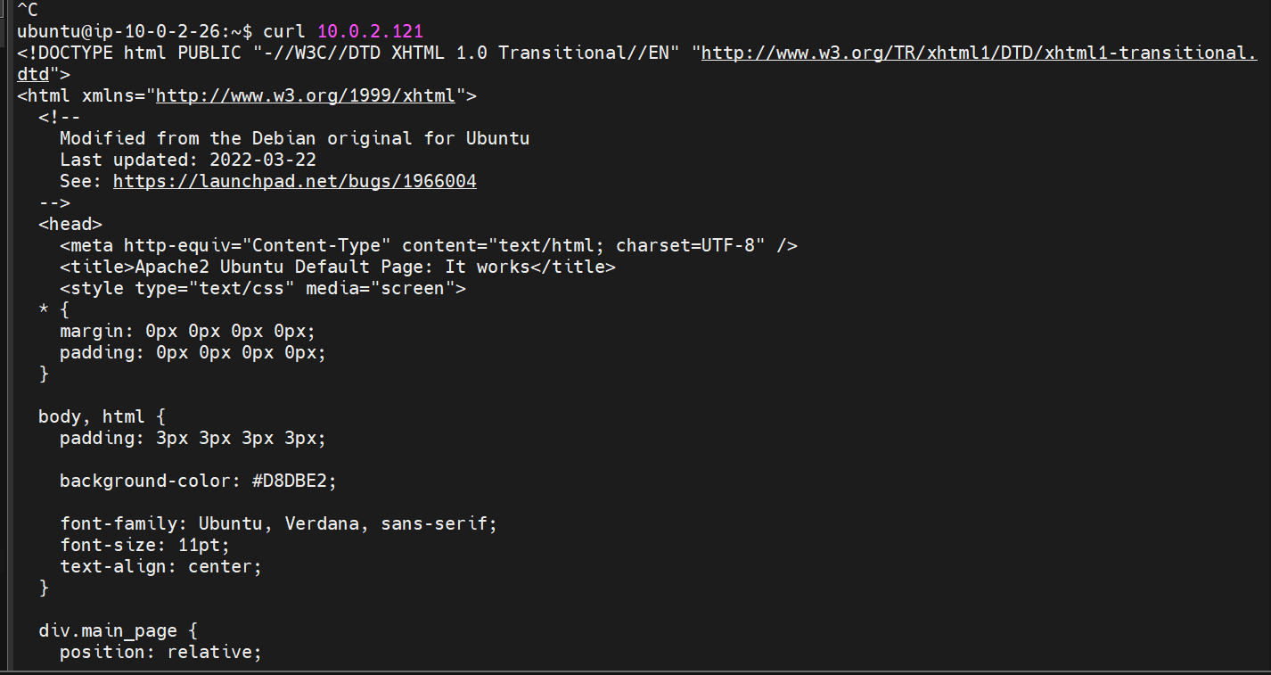

Public IP can be found using below path:

*Instances >> {stack-name}-inst2 >> Networking >> Elastic IP address >> copy ‘Allocated IPv4 address’ of {stack-name}-inst2-data-nic1-ip*

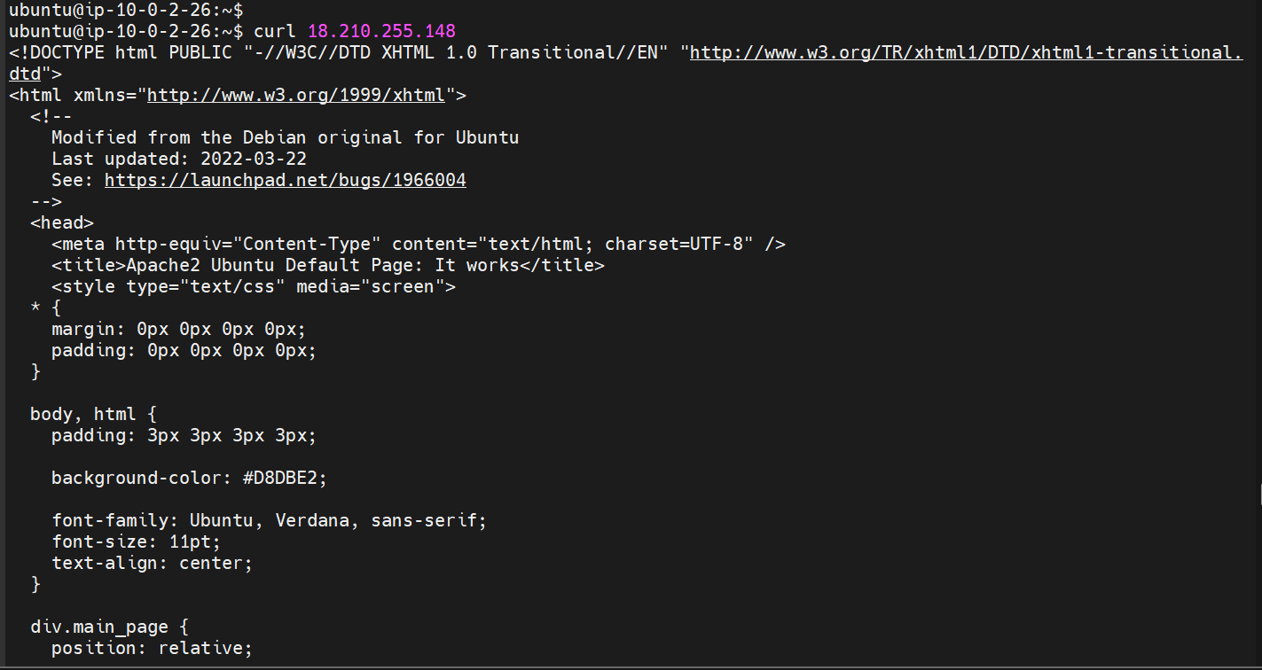

### GLM verification

Execute Command -> *show running-config*

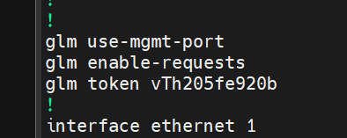

Execute Command -> *show license*

To see the host id



To check GLM License login to your vthunder.

Then go on your profile and select settings.

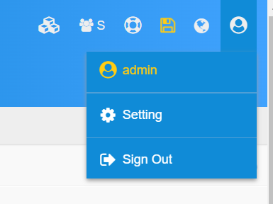

Then click on licensing.

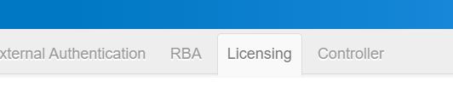

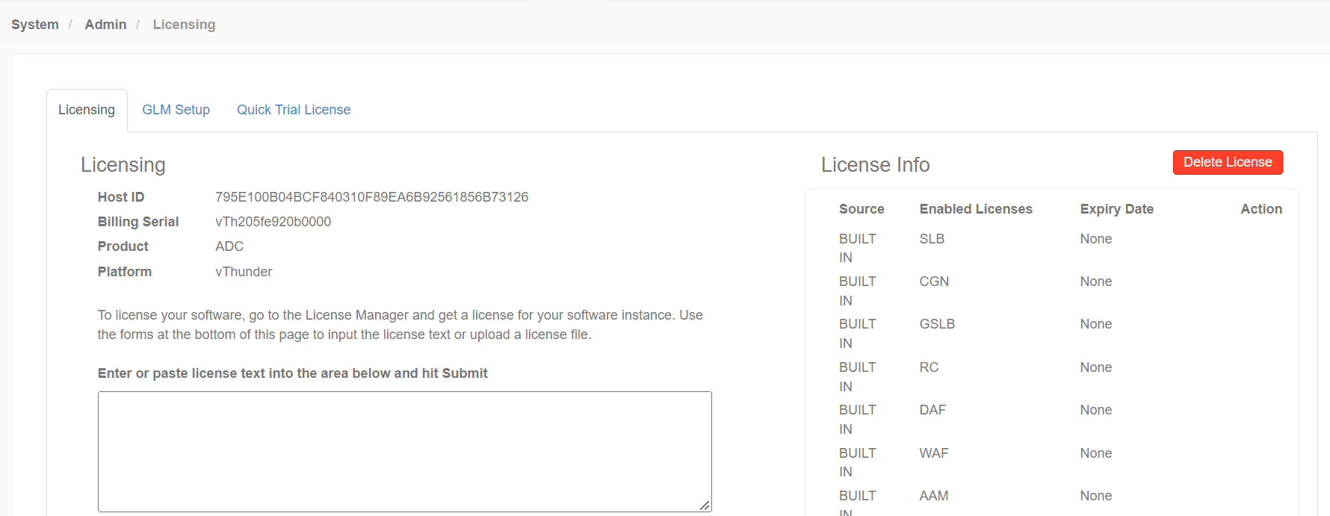

CloudFormation template should create 1vthunder with given configurations, configure vThunder as SLB, SSL and HA.

*Note: Lambda function deletion will get skipped while deleting stack, so you need to delete Lambda function manually using following steps:*

1. Go to path: Lambda >> Functions
2. Select Lambda function

1. Delete